**Chapter 1**

**Introduction to computer graphics**

* **Preliminaries**
* Computer is an information processing machine. User needs to communicate with the computer and the computer graphics is one of the most effective and commonly used ways of communication with the user.
* It displays the information in the form of graphical objects such as pictures, charts, diagrams and graphs.
* Graphical objects convey more information in less time and easily understandable formats for example statically graphs shown in stock exchange.
* In computer graphics picture or graphics objects are presented as a collection of discrete pixels.
* We can control intensity and color of pixels which decide how a picture looks.
* The special procedure determines which pixel will provide the best approximation to the desired picture or graphics object; this process is known as ***Rasterization***.
* The process of representing a continuous picture or graphics object as a collection of discrete pixels is called ***Scan Conversion*.**
  1. **Computer graphics basics**

* **What is computer graphics (CG)?**
* Computer graphics is an art of drawing pictures, lines, charts, etc. using a computer with the help of programming. **Pixel** is the smallest addressable graphical unit represented on the computer screen.
* ***Image*** represented as a 2D grid of “pixels” (picture elements) -Each pixel can take on a unique color value (Fig. 1)
* At a minimum, there is 1 memory ***bit*** for each pixel in the raster. This amount of memory is called a ***bit plane***.

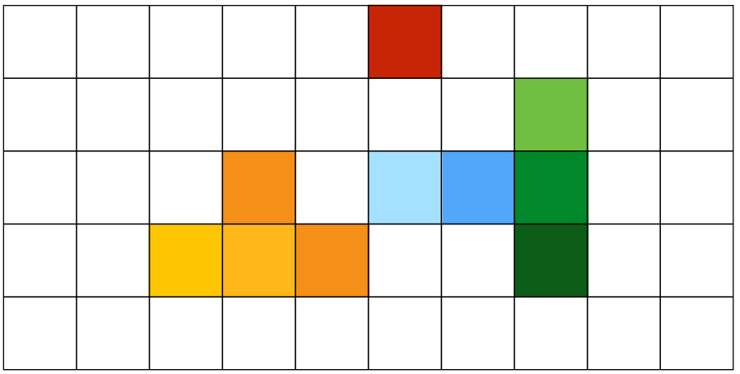

***Figure 1***: Example of 2D grid image

CG is the use of computers to create and manipulate pictures on a display device. It comprises of software techniques to create, store, modify, represents pictures.

**Computer graphics can also define as:**

* Algorithms, mathematics, data structures, etc. that computer uses to generate PRETTY PICTURES
* Computer graphics generally means creation, storage and manipulation of models and images.
  + Models come from different sets of fields including **physical, mathematical, biological** structures.
* Approaches, Methods, Techniques and Tools for virtual world visualization
* Cross-disciplinary fields in which physics, mathematics, human perception, human-computer interaction, engineering, graphic design and art all play important roles.
* **Why computer graphics?**
* Computer Graphics involves technology to access. The Process transforms and presents information in a visual form. The role of computer graphics is insensible. In today life, computer graphics has now become a common element in user interfaces, T.V. commercial motion pictures.
* Computer Graphics is the creation of pictures with the help of a computer. The end product of computer graphics is a picture; it may be a business graph, drawing, and engineering.
* Suppose a manufacturing company wants to show the sale of their product for five years. For this vast amount of information is to store. So a lot of time and memory will be needed. This method will be tough to understand by a common man. In this situation graphics is a better alternative. Graphics tools are charts and graphs. Using graphs, data can be represented in pictorial form. A picture can be understood easily just with a single look.
* Computer graphics is one of the most effective and commonly used ways of communication with computers.
* It provides tools for producing pictures of “real-world” as well as synthetic objects such as mathematical surfaces in 4D and of data that have no inherent geometry such as survey results.
* It has the ability to show moving pictures thus able to produce animations with computer graphics.
* With the use of computer graphics, we can control the animation by adjusting the speed, portion of picture in view, the amount of detail shown and so on.
* It provides tools called motion dynamics. In which users can move objects as well as observe as per requirement for example walk throw made by builder to show flat interior and surrounding.
* It provides a facility called update dynamics. With this we can change the shape color and other properties of the object.
* Now in the recent development of digital signal processing and audio synthesis chips the interactive graphics can now provide audio feedback along with the graphical feed backs.
  1. **Uses/Applications of Computer Graphics:**
* **User interface**: - Visual objects which we observe on screen which communicate with users are one of the most useful applications of the computer graphics.
  + Web Page interface, desktop application Interface
* **Plotting of graphics** and charts in industry, business, government and educational organizations drawing like bars, pie-charts, histograms are very useful for quick and good decision making.
* **Office automation and desktop publishing:** - It is used for creation and dissemination of information. It is used in in-house creation and printing of documents which contains text, tables, graphs and other forms of drawn or scanned images or pictures.
* **Computer aided drafting, engineering, and design**: - It uses graphics to design components and systems such as automobile bodies, structures of building etc (Fig. 2).

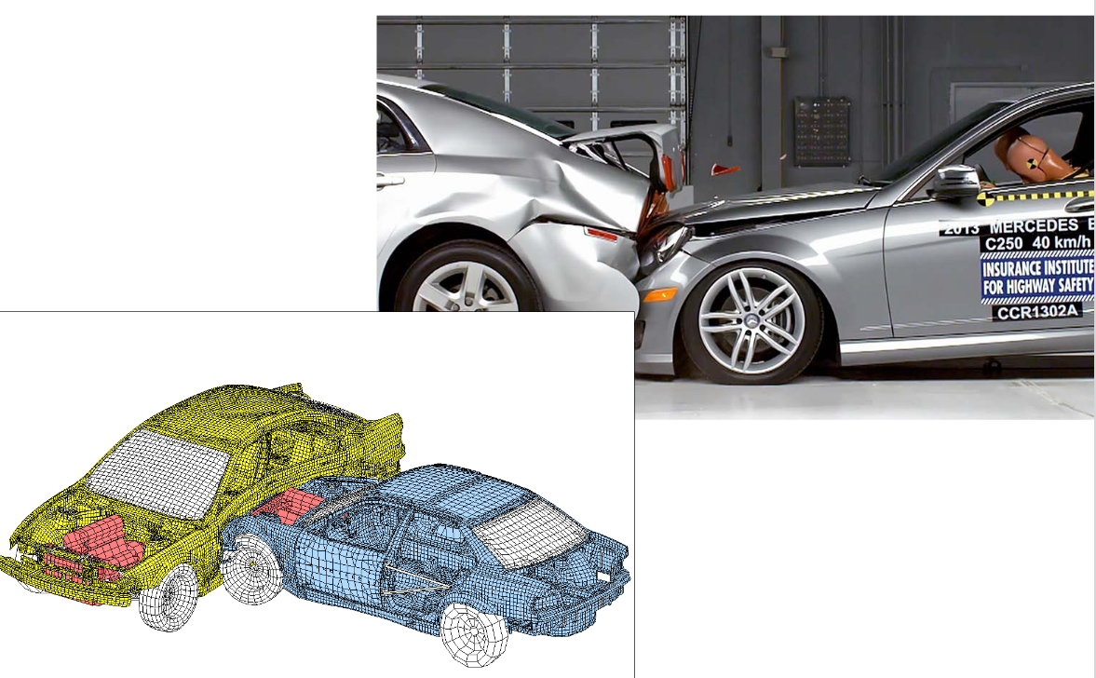

***Figure 2***: Example Computer aided drafting, engineering, and design

* **Simulation and animation**: - Use of graphics in simulation makes mathematical models and mechanical systems more realistic and easy to study (Fig. 3).

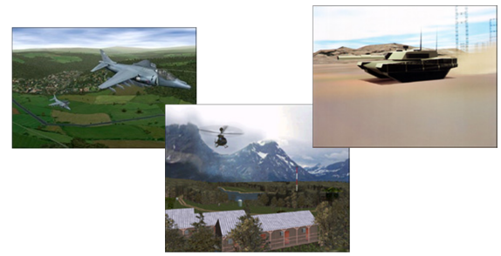

***Figure 3***: Example simulation and animation

* Process control: - Now a day’s automation is used which is graphically displayed on the screen.
* **Cartography**: - Computer graphics is also used to represent geographic maps, weather maps, oceanographic charts etc.
* **Education and training**: - Computer graphics can be used to generate models of physical, financial and economic systems. These models can be used as educational aids.
* **Art, entertainment, publishing, and commerce:**
  + There are many tools provided by graphics which allow users to make their picture animated and attractive which are used in advertising.
  + movies, TV, books, magazines, games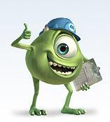 (Fig. 4)

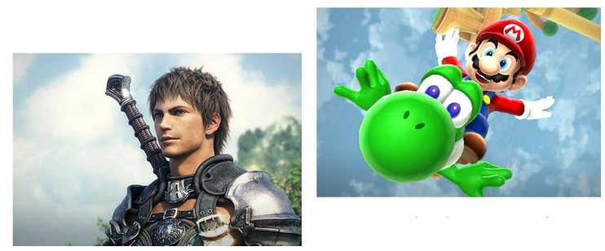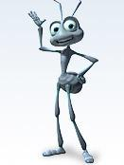

***Figure 4***: Example using computer graphics in entertainment

* **Image processing:**
  + Image processing: - It is used to process images by changing property of the image (Fig. 5).
  + EX. alter images and remove noise.

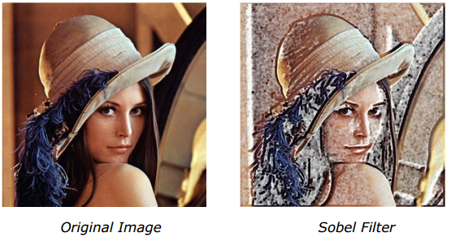

***Figure 5***: Example image processing

* **Process monitoring:**
  + Layout of large systems or plants
* **Scientific analysis and visualization:**
  + molecular biology, weather, matlab.

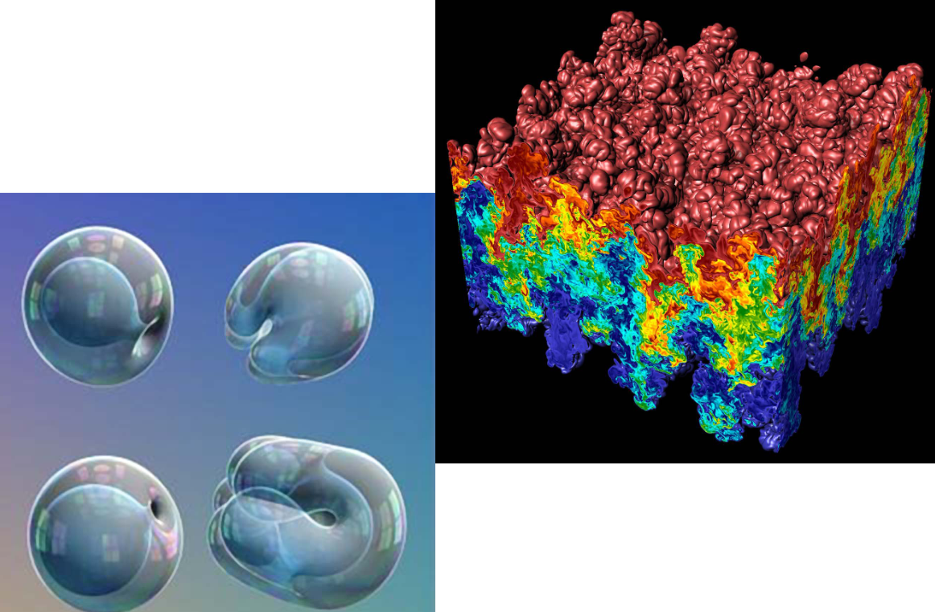

***Figure 6***: Example scientific analysis

* **Medical Application (Fig. 7)**

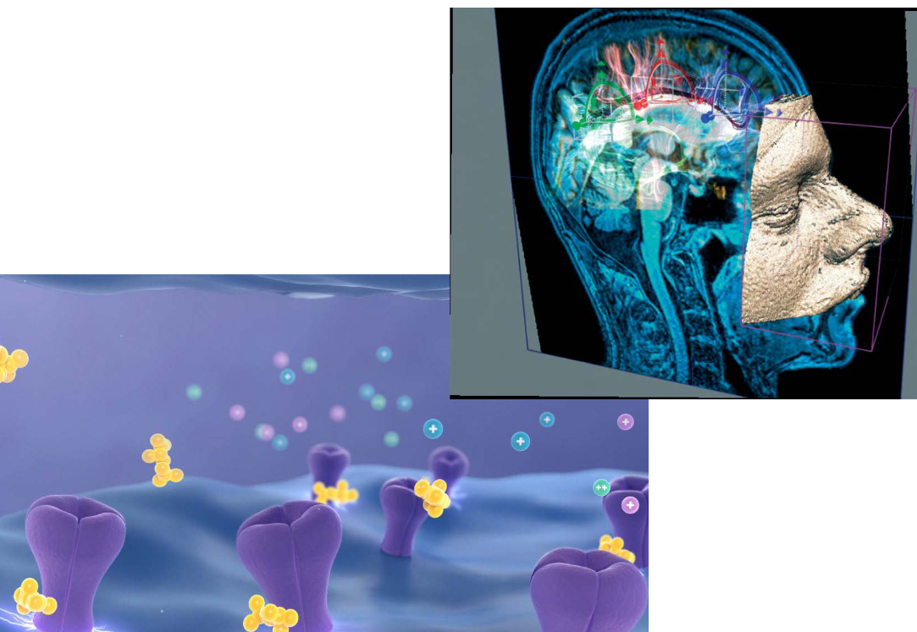

***Figure 7***: Example medical applications

* **Engineering (Fig. 8)**

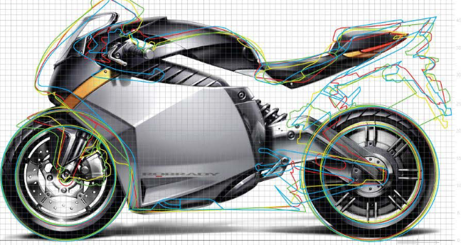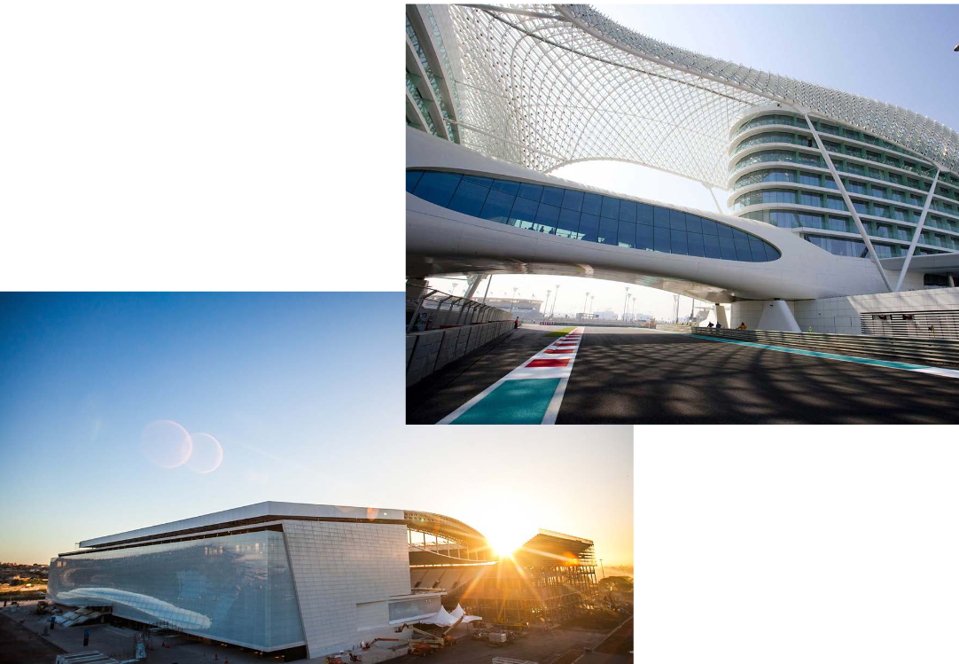

***Figure 8***: Example using computer graphics in engineering

* **navigation**

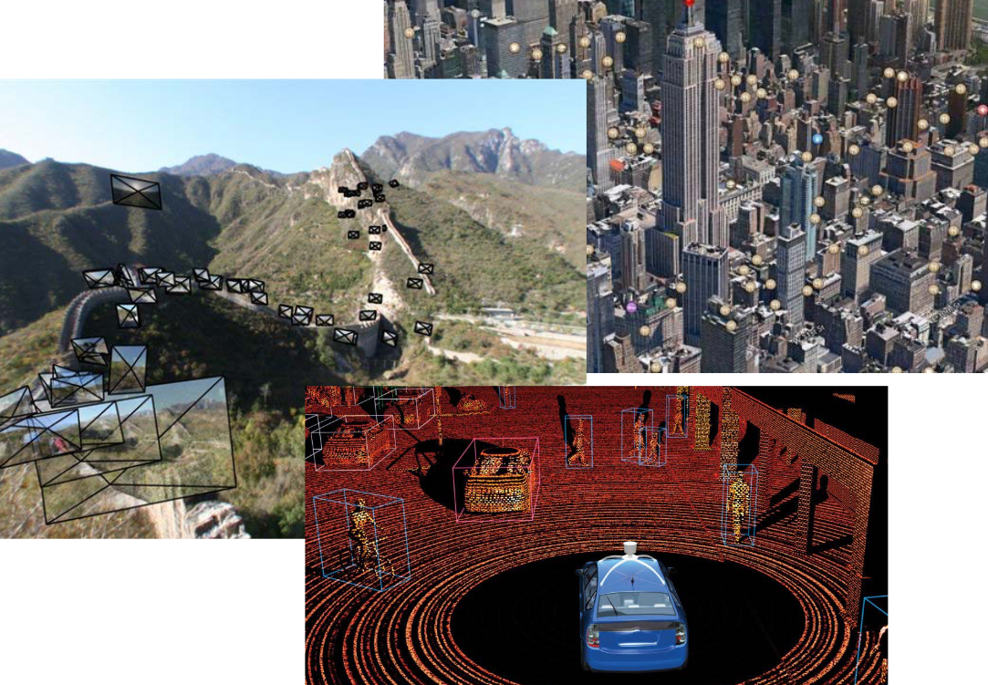

***Figure 9***: Example navigation

* **What Is the Difference Between 2D and 3D Modelling?**
* 2D and 3D modelling involve similar processes, and you can create both 2D and 3D models using [***computer-aided design***](https://www.takeoffpros.com/2019/10/29/difference-between-bim-and-cad/)***(CAD***), a set of software tools that assists designers in creating virtual models of structures, machines, components and other objects. However, 3D modelling takes things a step further by adding another dimension, as well as more information and capabilities***. What is the difference between 2D drawings and 3D models (table 1)***?
* **2D Modelling**
* 2D modelling involves creating blueprints, drawings and plans in two dimensions. These documents can describe the basic layout of a site, and where objects are placed, but they don’t include the dimension of depth. These 2D plans can be created on paper or in computer programs that are designed for creating models in two dimensions.
* **3D Modelling**
* The major difference between 2D and 3D modelling in CAD is that 3D modelling adds a third dimension. This means that 3D models contain more information than 2D models. They represent the finished site as it will look in real life. 2D models, on the other hand, provide valuable information, but viewers are left to imagine what the final product will look like. 3D models are created in advanced computer programs and incorporate data from [Light Detection and Ranging](https://www.takeoffpros.com/2019/11/26/lidar-surveying-explained/) (LIDAR) equipment, the Global Positioning System (GPS) and [aerial photogrammetry](https://www.takeoffpros.com/services/photogrammetry/). 3D models can contain a wide range of information types and can be used for grading, site layout and other purposes, in addition to the uses of 2D modelling.

***Table 1***: a comparison between 2D model and 3D model

|  |  |
| --- | --- |
| **2D model** | **3D model** |
| * Flat * (x, y) color values on screen * Objects no depth or distance from viewer | * Life-like * (x, y, z) values on screen * Perspective: objects have distances from viewer |
| http://www.dataviews.de/products/hmigo/images/stattody.gif | http://hendrix.ei.dtu.dk/image/twod/vrmlBlobsAndDrury2000.jpg |

* **Four Main Operations of Computer Graphics:**
* Image Editing
* 3D Modelling
* 2D Rendering
* Animation
* **Image Editing:**
* Imaging:
  + The operations that generate and manipulate the image features.
  + It consists of two types of operations: image editing and image processing.
    - **Image Editing:** 
      * If the operation performed by the user
    - **Image editing operations:**
      * Image Merging (Fig. 10)



***Figure 10***: Example image merging

* + - * Change Color
      * Image Cropping (Fig. 11)

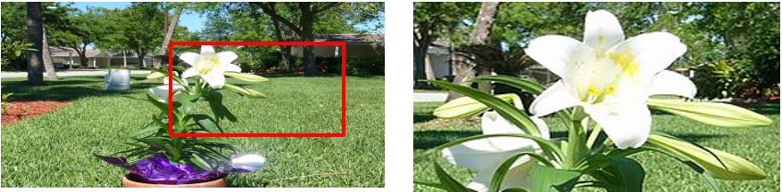

***Figure 11*** Example image cropping

* + - * Image Orientation (Fig. 12)

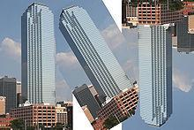

***Figure 12***: Example image orientation

* **3D Modelling:**
* Represents a 3D object using a collection of points in 3D space, connected by various geometric entities such as lines, triangles, curves, ….
* Construct the ***3D*** model of the scene.
* **How to represent real environments:**
  + - * **Geometry:** Lines, triangles, curves, surfaces, Cylinder, spheres
      * **Photometry**: light, color, shadow

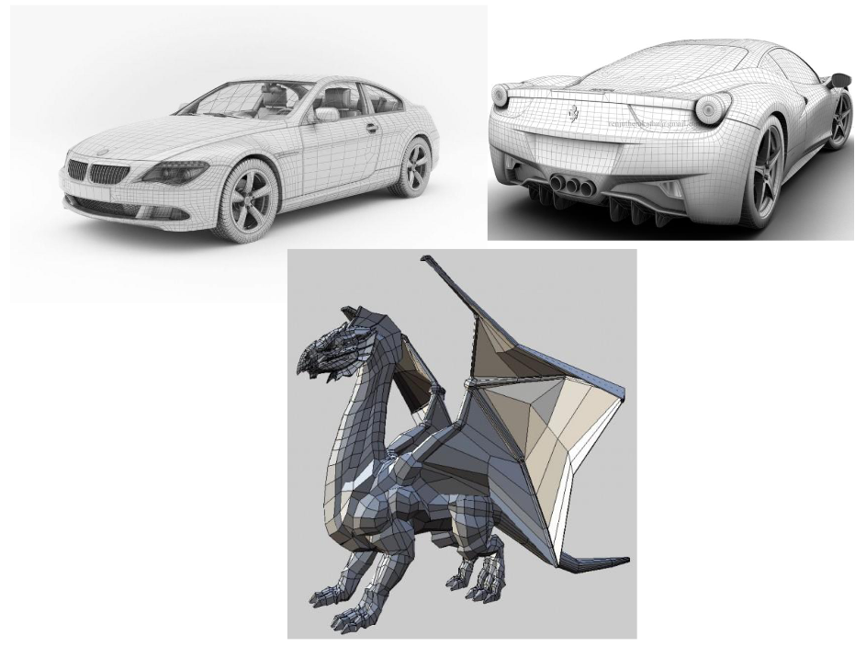

***Figure 13***: Example 3D models

* **2D Rendering:**
* 2D Rendering is the opposite operation of 3D modelling process
* It is responsible for creating 2D images from a model or 3D image by means of computer programs.
* Converting 2D/3D information into pixels
* Compute the color of each pixel

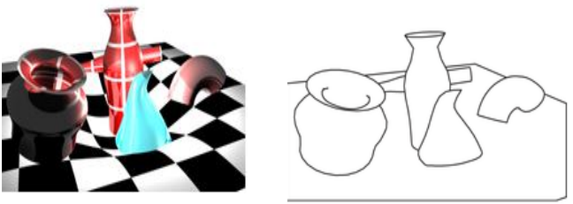

***Figure 14***: Example 2D rendering

* **Animation:**
* Is the process used for moving or simulating the movement of objects over time.
* Changing properties over time to give an illusion of motion
* **Animation is done by temporal change of:**
  + **Adding** or **removing** objects
  + **Object** (position, orientation, size, shape, color)
  + **Camera** (position, direction, angle, focus, etc.)
  + **Lighting** (position, direction, color, brightness)

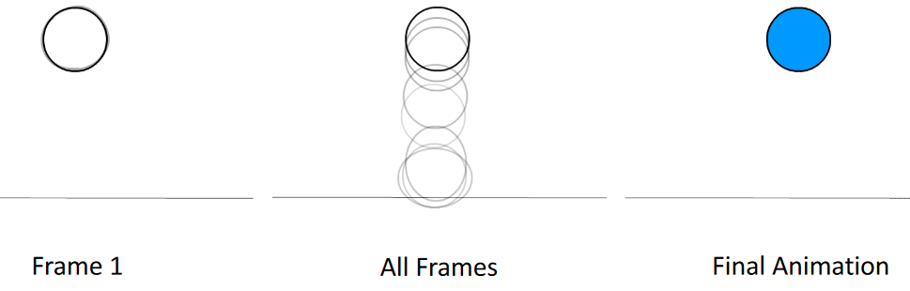

***Figure 15***: Example animation

* **Interactive and Passive Graphics**

***Table 2***: A comparison between interactive and non-interactive computer graphics

|  |  |
| --- | --- |
| **(a) Non-Interactive or Passive Computer Graphics:** | **(b) Interactive Computer Graphics:** |
| In non-interactive computer graphics, the picture is produced on the monitor, and the user does not have any control over the image, i.e., the user cannot make any change in the rendered image. One example of its Titles shown on T.V. | In interactive Computer Graphics users have some control over the picture, i.e., the user can make any change in the produced image. One example of it is the ping-pong game. |
| Non-interactive Graphics involves only one-way communication between the computer and the user, User can see the produced image, and he cannot make any change in the image. (Ex. movies) | Interactive Computer Graphics requires two-way communication between the computer and the user. A User can see the image and make any change by sending his command with an input device.(Ex. games) |

* **Computer Graphics software**
* Can be classified according to many factors, such as
  + **Operation supporting** (2D manipulation, 3D modeling, animation ...)
  + **Hardware independent** and operating system compatibility
  + **Type of application** (desktop, web or mobile based)
  + **Based on image representation** (raster or vector)
  1. **Components of computer graphics system:**
* **Input Devices**
* Keyboard, Mouse, Joystick, Touch Screen….
* Each input device has properties that makes it more suitable for certain tasks than for others
* Input devices can be classified into two categories: pointing devices and keyboard devices.

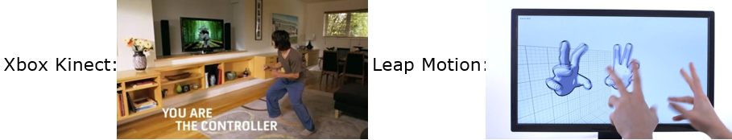

***Figure 16***: Example input devices

* **Data**
* Image
* **Processing**
* CPU, GPU
* **Memory**
* Frame buffer
* **Output devices**
* CRT, LCD, Touch Screen

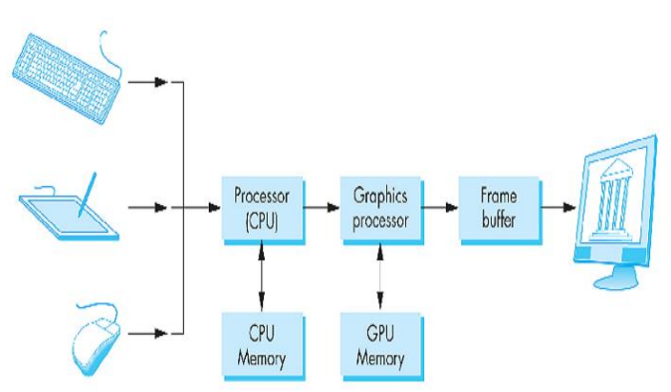

***Figure 17***: CG application lifecycle

* **Computer Graphics Software**

**CPU (central processing unit):**

* The main graphical function of the processor is to take specifications of graphical primitives (such as lines, circles) generated by application programs and to assign values to the pixels.
* In simple systems the CPU does both normal and graphical processing.

**GPU (graphics processing unit):**

* Graphics systems are characterized by special purpose graphics processing units (GPUs).
* The GPU is similar to a computer's CPU.
* Designed to perform complex mathematical and geometric calculations that are necessary for graphics rendering.
* Responsible for rasterizing/digitizing a picture into a set of pixels in the frame buffer.

**Rasterizing**: Conversion of geometric objects into pixels

* Contains over 100 processing units each of which is user programmable.
* Powerful so it can be used as mini supercomputers for general purpose computing.
* **Raster and vector images**

***Table 3***: A comparison between raster and vector images

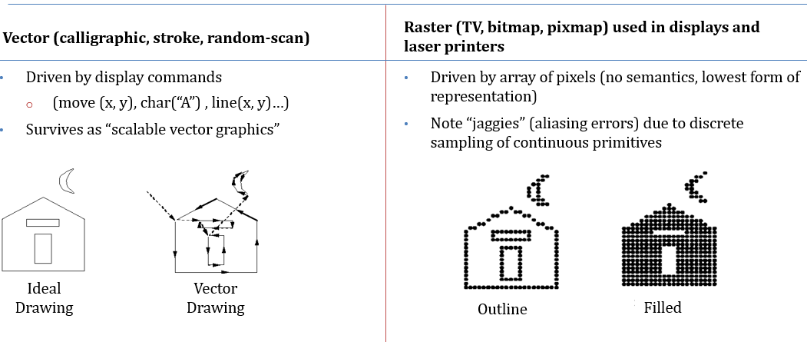

* **Working of Interactive Computer Graphics:**
* The modern graphics display is very simple in construction. It consists of three components:

1. Frame Buffer or Digital Memory
2. A Monitor likes a home T.V. set without the tuning and receiving electronics.
3. **Display Controller or Video Controller:** It passes the contents of the frame buffer to the monitor.

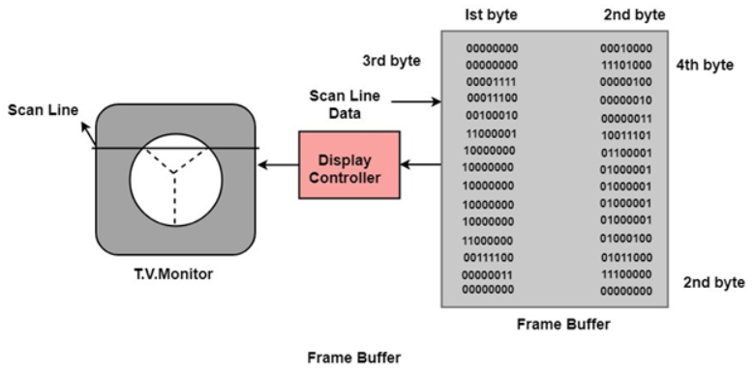

***Figure 18***: frame buffer

* **Frame Buffer:**

Can be defined as:

* The memory to hold the pixel properties (color, depth).
* The area of memory reserved for direct manipulation of the currently displayed image.
* Any piece of storage that represents an image.
* The frame buffer is stored in the memory chips on the video adapter.
* The video chipset may be integrated into the motherboard design, and the frame buffer is stored in general main memory.
* **Frame buffer's resolution:**
* The number of pixels in the frame buffer determines the detail that you can see in the image.
  + - * + **Properties of a frame buffer that affect the graphics performance:**
  + **Size:** number of pixels in the frame buffer.
  + **Depth**: number of bits used for each pixel
  + 1 bit/pixel: black and white
  + 8 bits/pixel: 256 levels of gray or color pallet index
  + 24 bits/pixel: 16 million colors
  + **Speed:** refresh speed
  + **Notes:**
* Frame buffer is a large, contiguous block of memory to manipulate the pixels of an image currently shown in the computer's display.
* By reading or writing to the frame buffer, we can read or write the color values of pixels at particular positions on the display.
* The color values of the pixels are stored in a frame buffer by GPU.
* GPU is a processor in video adapter not to deal with memory of ram but with frame buffer.

**Frame buffer's depth**: determines how many colors can be represented on a given system.

* **Frame Buffer Format:**
* Monochrome Frame buffer:
  + A frame buffer is said to **be monochrome** **on a black and white system** with **one bit per pixel**.
* Grayscale Frame Buffer:
  + Encode pixels using various shades of grey.
  + Pixels are encoded as an unsigned integer using 8 bits, so can represent 256 different shades of grey.
* Indexed Color Frame Buffer
  + Allow representation of color images.
  + The storage scheme is identical to the grey scale buffer.
  + Pixel values do not represent a particular color but instead an index into a list of 256 different colors.
* True Color Frame Buffer
  + Represents colored image.
  + The RGB color value for each pixel is stored directly within the frame buffer.
  + Uses 3 bytes for each pixel (24 bits) of storage.
  + Can represent all colors at once.
  + Takes 3 times as much storage as indexed image
* **Raster scan:**
* The display reads the color values from the frame buffer row by row, from left-to-right, top-to-bottom and put each of the values onto the screen 🡪 this known as raster scan.
* **Computer Display Device:**
* Modern graphic system consists of a few interaction devices (keyboard, mouse, touch screen), a CPU, a GPU, and a display
* Today's display is either LCD or CRT displays.
  1. **Display concepts:**
* The most commonly used display device is a video monitor. The operation of most video monitors based on CRT (Cathode Ray Tube). The following display devices are used:
  + Cathode Ray Tube
  + Random Scan and Raster Scan
  + Color CRT Monitors
  + Direct View Storage Tubes
  + Flat Panel Display
  + Lookup Table
* **Cathode Ray Tube (CRT):**
* CRT stands for Cathode Ray Tube. CRT is a technology used in traditional computer monitors and televisions. The image on the CRT display is created by firing electrons from the back of the tube of phosphorus located towards the front of the screen (Fig. 19).
* Once the electron heats the phosphorus, they light up, and they are projected on a screen. The color you view on the screen is produced by a blend of red, blue and green light.

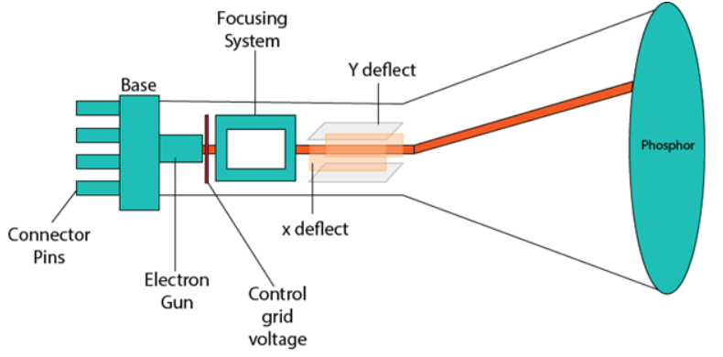

***Figure 19***: CRT

* **Components of CRT:**
* **Electron Gun:** Electron gun consisting of a series of elements, primarily a heating filament (heater) and a cathode. The electron gun creates a source of electrons which are focused into a narrow beam directed at the face of the CRT.
* **Control Electrode:** It is used to turn the electron beam on and off.
* **Focusing system:** It is used to create a clear picture by focusing the electrons into a narrow beam.
* **Deflection Yoke:** It is used to control the direction of the electron beam. It creates an electric or magnetic field which will bend the electron beam as it passes through the area. In a conventional CRT, the yoke is linked to a sweep or scan generator. The deflection yoke which is connected to the sweep generator creates a fluctuating electric or magnetic potential.
* **Phosphor-coated screen:** The inside front surface of every CRT is coated with phosphors. Phosphors glow when a high-energy electron beam hits them. Phosphorescence is the term used to characterize the light given off by a phosphor after it has been exposed to an electron beam.
* **Random Scan Display:**
* Random Scan System uses an electron beam which operates like a pencil to create a line image on the CRT screen. The picture is constructed out of a sequence of straight-line segments. Each line segment is drawn on the screen by directing the beam to move from one point on the screen to the next, where its x & y coordinates define each point. After drawing the picture. The system cycles back to the first line and designs all the lines of the image 30 to 60 times each second. The process is shown in fig. 20:

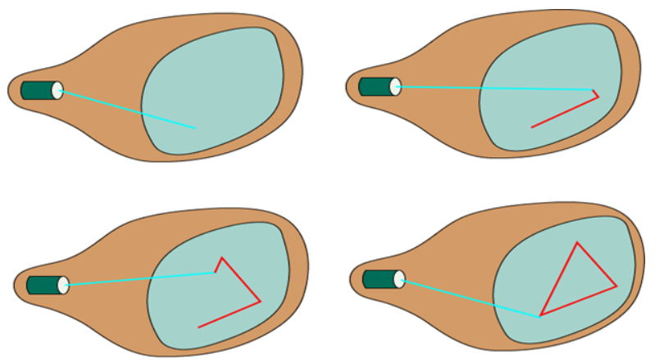

***Figure 20***: Random scan display

* Random-scan monitors are also known as vector displays or stroke-writing displays or calligraphic displays.

**Advantages:**

* A CRT has the electron beam directed only to the parts of the screen where an image is to be drawn.
* Produce smooth line drawings.
* High Resolution

**Disadvantages:**

* Random-Scan monitors cannot display realistic shades scenes.
* **Raster Scan Display:**
* A Raster Scan Display is based on intensity control of pixels in the form of a rectangular box called Raster on the screen. Information of on and off pixels is stored in refresh buffer or Frame buffer. Televisions in our house are based on the Raster Scan Method. The raster scan system can store information of each pixel position, so it is suitable for realistic display of objects. Raster Scan provides a refresh rate of 60 to 80 frames per second.
* Frame Buffer is also known as Raster or bitmap. In Frame Buffer the positions are called picture elements or pixels. Beam refreshing is of two types. First is horizontal retracing and second is vertical retracing. When the beam starts from the top left corner and reaches the bottom right scale, it will again return to the top left side called at vertical retrace. Then it will again more horizontally from top to bottom call as horizontal retracing shown in fig 21:

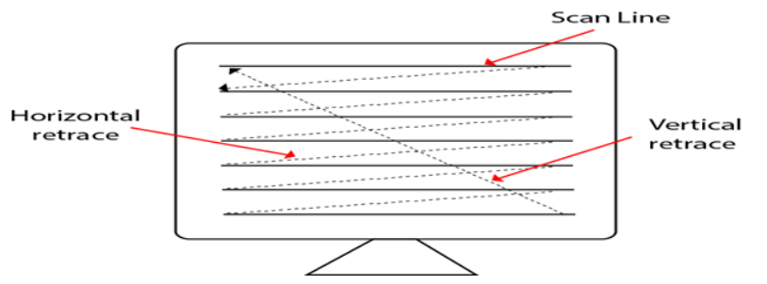

***Figure 21***: Raster scan display

***Table 4***: A comparison between random scan and raster scan

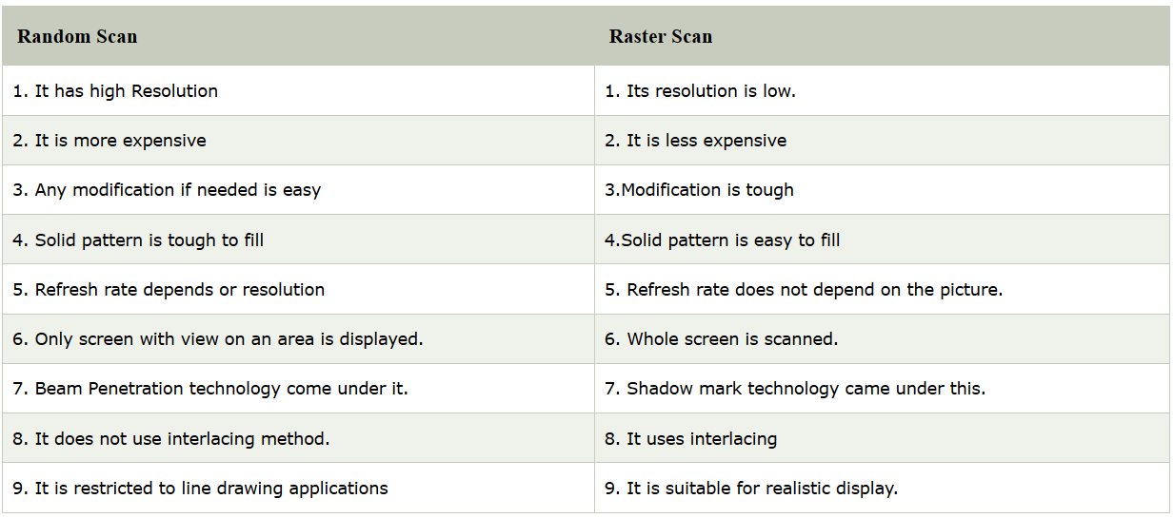

* **Look-Up Table:**
* Image representation is essentially the description of pixel colors. There are three primary colors: R (red), G (green) and B (blue). Each primary color can take on intensity levels and produces a variety of colors. Using direct coding, we may allocate 3 bits for each pixel, with one bit for each primary color. The 3-bit representation allows each primary to vary independently between two intensity levels: 0 (off) or 1 (on). Hence each pixel can take on one of the eight colors.
* A widely accepted industry standard uses 3 bytes, or 24 bytes, per pixel, with one byte for each primary color. This way, we allow each primary color to have 256 different intensity levels. Thus a pixel can take on a color from 256 x 256 x 256 or 16.7 million possible choices. The 24-bit format is commonly referred to as the actual color representation.
* Lookup Table approach reduces the storage requirement. In this approach pixel values do not code colors directly. Alternatively, they are addresses or indices into a table of color values. The color of a particular pixel is determined by the color value in the table entry that the value of the pixel references. Figure shows a look-up table with 256 entries. The entries have addresses 0 through 255. Each entry contains a 24-bit RGB color value. Pixel values are now 1-byte. The color of a pixel whose value is i, where 0 <i<255, is persisted by the color value in the table entry whose address is i. It reduces the storage requirement of a 1000 x 1000 image to one million bytes plus 768 bytes for the color values in the look-up table.

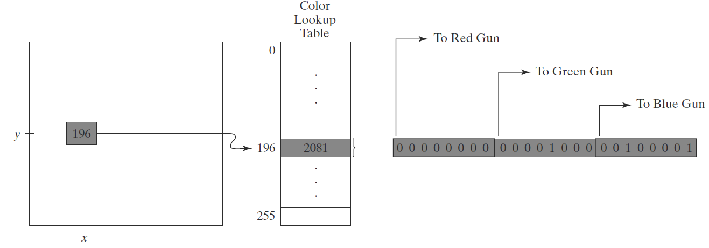

***Figure 22***: Example for lookup table

* **Display characteristics:**
* There are some parameters or properties related to display such:
* Screen "resolution":
  + The number of dots per unit length that can be plotted horizontally and vertically.
  + A measure of its ability to distinguish fine detail.
  + Max number of points that can be displayed without overlap.
* **Bitmap and Pixmap:**
* Bitmap:
  + is a frame buffer on a black and white system with one bit per pixel.
* Pixmap:
  + For systems with multiple bits per pixel the frame buffer is called Pixmap.
* **Notes:**
* Increasing the distance between dots, decreases the number of dots per inch (dpi) and this decreases the device resolution.
  + Because a lot of information will be discarded.
  1. **Graphics software and standard**
* General programming package
* Special-purpose application package
* **General programming package**
* A general programming package provides an extensive set of graphics functions that can be used in high level programming language such as C or FORTRAN.
* It includes basic drawing element shapes like line, curves, polygon, color of element transformation etc.
* Example: - GL (Graphics Library).
* **Special-purpose application package**
* Special-purpose application package is customizing for particular applications which implement the required facility and provide an interface so that users need not vary about how it will work (programming). Users can simply use it by interfacing with applications.
* Example: - CAD, medical and business systems.
* **Graphics library:**
* Is an intermediary between application and hardware.
* Application programs map application objects to views (images) of those objects by calling on the graphics library.
* The programmer who sets out to write a graphics program has a wide choice of starting points
* Because graphics cards (the hardware that generate data to be displayed on a screen) are different from one machine to the next:
  + It's typical to use some kind of software abstraction called application programming interface (API)
* Examples:

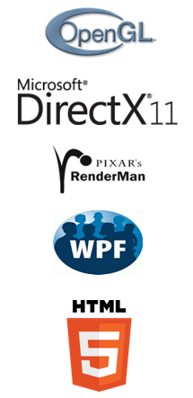

* + OpenGL, DirectX, windows

presentation foundation, HTML5

* + HTML5 + WebGL™
  + Unity 2D/3D
  + Three.JS
* **Batch Computer Graphics**
* Today, we still use non-interactive batch mode (aka offline rendering) for final production-quality video and film (special effects – FX). Rendering a single frame of Finding Dory (2016, a 24 fps movie) averaged 53 hours on a 30,000-core render farm!
* **Moore’s Law:** every 12-18 months, computer power improves by factor of 2 in price / performance as size shrinks
* Newest CPUs are 64-bit with 4, 8, 16, even 56 cores

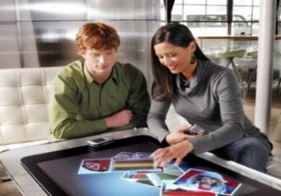

**Microsoft’s first Surface**

* **Enabling Modern Computer Graphics**

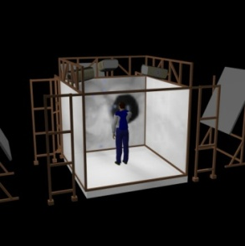

**Brown’s old Cave**

**Android Phones**

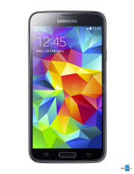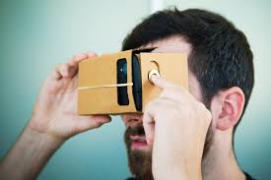

**Google Cardboard**

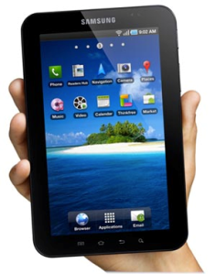

**Tablets**

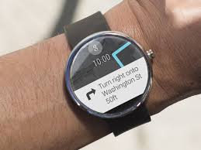

**Android Wear**

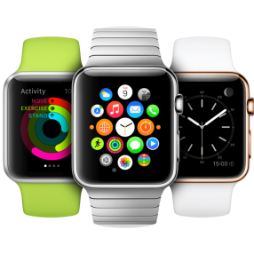

**Apple Watch**

**Oculus Rift**

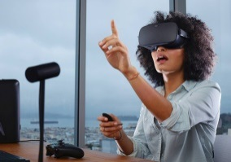

* Smartphones/laptops/desktops/tablets
* Smart watches
* Head-mounted displays (HMDs)



**Tablets**

* Augmented Reality
* Virtual Reality
  1. **Raster and vector images**
* **Pixel**: In Computer graphics a pixel, dots, or picture element is a physical point in a picture. A pixel is simply the smallest addressable element of a picture represented on a screen.
* A majority of pictures that we see on our computer screen are raster images. The selfie that you click with your mobile phone is another example of a raster image. An image is made up using a collection of pixels referred to as a bitmap.
* **Bitmap**: In computer graphics, a bitmap is a mapping from some domain (for example, a range of integers) to bits, that is, values which are zero or one. It is also called a bit array or bitmap index. The more general term pixmap refers to a map of pixels, where each one may store more than two colors, thus using more than one bit per pixel. Often bitmap is used for this as well. In some contexts, the term bitmap implies one bit per pixel, while pixmap is used for images with multiple bits per pixel.
* **Aspect Ratio:** An aspect ratio is an attribute that describes the relationship between the width and height of an image. Aspect ratio is expressed by the symbolic notation: X: Y. The values of X and Y are not the actual width and height of the image, but describe the relationship between them.
* **Resolution**: Image resolution is typically described in pixels per inch (PPI), which refers to how many pixels are displayed per inch of an image.
* Higher resolutions mean that there are more pixels per inch (PPI), resulting in more pixel information and creating a high-quality, crisp image.
* PPI describes the resolution in pixels of a digital image whereas DPI describes the amount of ink dots on a printed image.
* Though PPI largely refers to screen display, it also affects the print size of your design and thus the quality of the output. DPI, on the other hand, has nothing to do with anything digital and primarily concerns print.
* PPI, or pixels per inch, refers both to the fixed number of pixels that a screen can display and the density of pixels within a digital image. Pixel count on the other hand refers to the number of pixels across the length and width of a digital image
* Use PPI whenever you are working with digital images.
* **Modelling Vs Rendering:**
* **Modelling** is the process of making any object as a 3D object; rendering is all about giving a virtual life to any object in the virtual world.

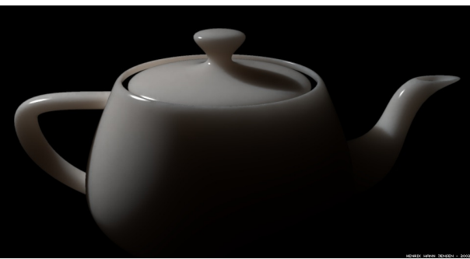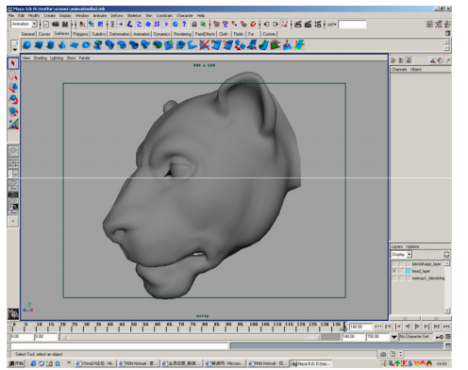

***Figure 23***: Example modelling

* **Sample-based graphics and geometry-based graphics**

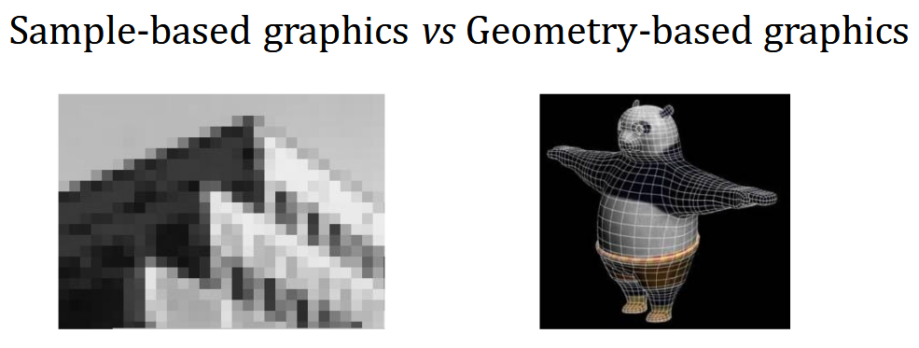

***Figure 24***: Example sample and geometry based graphics

* **Sample-based Graphics:**
  + discrete samples are used to describe visual information
  + pixels can be created by digitizing images, using a sample-based "painting" program, etc.
  + often some aspect of the physical world is sampled for visualization, e.g., temperature across the US
* ***Example programs:*** Adobe Photoshoot, GIMP, Adobe AfterEffectsTM
  + Images are made up of grids of discrete pixels, or 2D "picture elements"
  + Pixels are point locations with associated sample values, usually of light intensities/colors, transparency, and other control information
  + When we sample an image 🡺 we sample the point location along the continuous signal and we cannot treat the pixels as little circles or squares
  + Samples created directly in paint-type programs, or as sampling of continuous (analog) visual materials.
  + Sample values can also be input numerically (e.g., with numbers from computed dataset)
  + Once an image is defined as pixel-array, it can be manipulated
* **Image editing:** changes *made by user*, such as cutting and pasting sections, brush-type tools, **and processing selected areas**
* **Image processing:** **algorithmic operations that are performed on image** (or pre-selected portion of image) without user intervention.
* **Sampling an Image**
  + A color value is measured at every grid point and used to color the corresponding grid square.

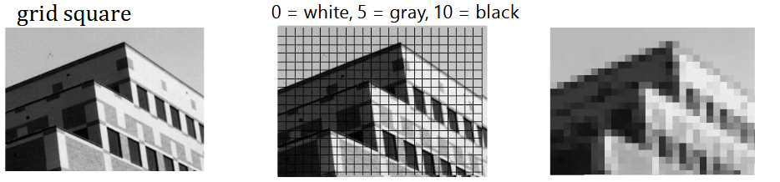

***Figure 25***: Example image sampling

* **Advantages of Sampling Images**
  + Once image is defined in terms of colors at (x, y) locations on grid, can change image easily by altering location or color values
  + Pixel information from one image can be copied and pasted into another, replacing or combining with previously stored pixels
* **Disadvantages of Sampling Images:**
  + WYSIAYG (What You See Is All You Get): No additional information
  + no depth information
  + can’t examine scenes from different points of view, at most can play with the individual pixels or groups of pixels to change colors, enhance contrast, find edges, etc.
* **Geometry-Based Graphics**
  + Geometry-based graphics applications store mathematical descriptions, or “models,” of geometric elements (lines, polygons, polyhedrons. . . ) and associated attributes (e.g., color, material properties).
  + Elements are primitive geometric shapes, primitives for short Images created as pixel arrays (via sampling of geometry) for viewing, but not stored as part of the model.
  + Users cannot usually work directly with individual pixels in geometry-based programs.
  + Increasingly rendering combines geometric and sample-based graphics, both as performance hack and to increase quality of final product
* **Geometric Modelling**
  + Captures salient features (data, behavior) of a thing/phenomenon being modelled data includes geometry, appearance, attributes.
  + Similarity to OOP ideas
  + Modeling allows us to cope with complexity
  + Some geometry inherent physical (e.g., actual object such as a chair), non-physical (e.g., mathematical function, weather data)
* **Decomposition of Geometric Model:**
  + Divide and Conquer
  + Hierarchy of geometrical components
  + Reduction to primitives (e.g., spheres, cubes, etc.) item

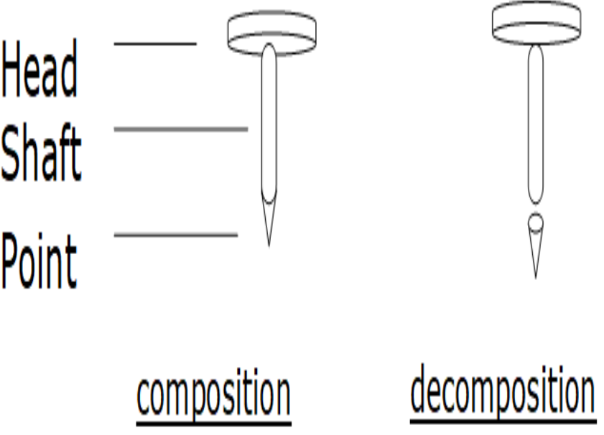

***Figure 26***: Example of decomposition

* + Object to be modelled is (visually) analysed, and then decomposed into collections of primitive shapes.
  + Tree diagram provides visual method of expressing "composed of" relationships of model
  + Such diagrams are part of 3D program interfaces (e.g., 3D Studio MAX, Maya)
  + As a data structure to be rendered, it is called a scenography

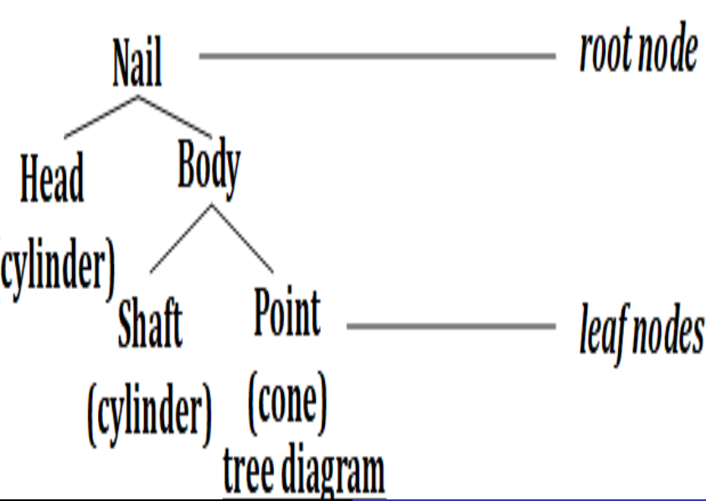

***Figure 27***: Example hierarchical models

* 1. **Image Formats:**

### Basic Terms:

* **Bit depth**
* The number of bits used to store color information
  + One bit: two possible values (0, 1)
  + Two bits: four values (00, 01, 10, 11)
  + So, the number of possible values **(# of colors)** is **2n**
    - where n is the **number of bits per pixel**
* **Color Depth**
* Color depth refers to the number of colors in an image.
* The more colors the image uses, the more colors that the image needs to keep track of, and the more bits that are needed to store each pixel.
* **PPI describes the resolution in pixels of a digital image whereas DPI describes the amount of ink dots on a printed image.**
* **Changing Color Depth**
* For a bitmap or raster image, changing the color depth changes the size of the file by a precise predictable amount.
* With compression, these ratios can vary, but they’re still a good rule of thumb
* **Changing Resolution**
* It is possible to greatly reduce the size of an image by reducing the number of pixels used to represent the image
* **Transparency**
* Some images include information on transparency encoded into the image.
* GIF images may include one transparent color in the color index table, allowing one “color” of the image to be transparent.
* PNG images can be indexed or true color and may include an additional byte of information per color (the alpha channel), which determines how transparent a particular pixel or color is.
* Faked "transparency”: the image is created and saved on a background to match the web page background.
* Not always a perfect match on older computers or on jpegs.
* Real transparency: the image background is transparent, so the image floats on the web page background color.
* **Interlacing**
* Normally, an image appears as a line-by-line download.
* Interlacing 🡺 visitors see a complete but low resolution, very pixelated version that is  
  incrementally replaced by higher resolution versions

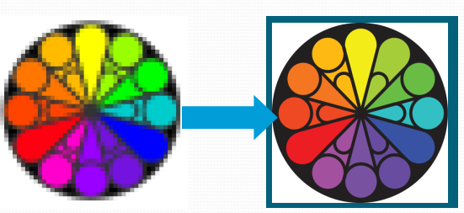

***Figure 28***: Example interlacing

* Interlacing may actually increase the download time a bit, but visitors may perceive it as faster.
* **Dithering**

The process of approximating colors you don't have by mixing colors you do have.

* **In the world of digital imaging there are two types of graphical image files that you need to be aware of.**

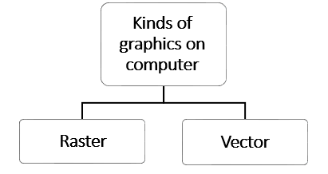

* **Raster Formats**
* Raster images are also called bitmap images because they are made up of tiny squares called pixels each pixel contains exactly 1 color.

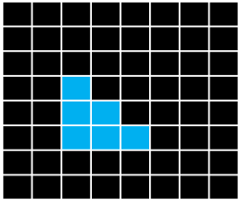

* GPU Break the image (picture) up into a regular grid that we call a ‘raster’ or bitmap.
  + Each grid cell is called a pixel.
  + The pixel is the **atomic unit of the image.**
    - It is colored uniformly.
* The process of breaking the image into grid of pixel called **Rasterization**

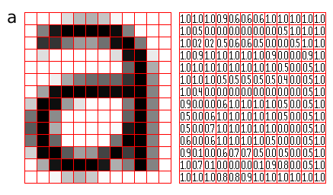

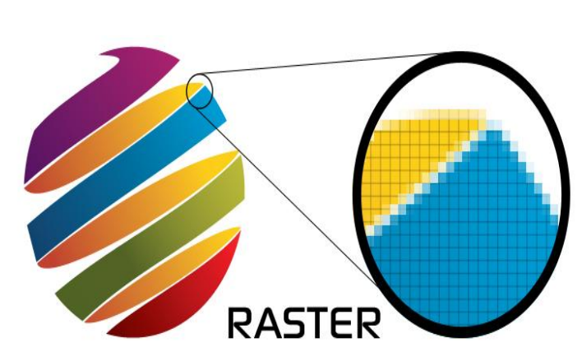

* **Raster image Resolution:**
* The physical size of an image when it is displayed will depend on the pixel density of the device it is to be displayed on.
* **Resolution and pixel dimensions**
* The low resolution version is coarse, with individual pixels clearly discernible at modest magnification. This called **pixelation**
* The pixel dimensions determine how much detail is contained in the image.
* The number of dots per inch on the output device tells you how big that image will be and how easy it will be to see the individual pixels.
* We want the image to be displayed at its natural size, irrespective of the resolution of the output device.
  + **In order to allow this**, most image formats record **a resolution with the image data**.
  + **Alternatively, we could associate a fixed size in some** appropriate units, but this is less convenient.
* The stored resolution will be that of the device from which the image originated, where this makes sense.
* A simple matter for software that display the image to ensure that is appears at its natural size, by scaling it by a factor of:

**device resolution/ image resolution.**

* **Example:**
* An image to be displayed on a 72 dpi monitor:
* For displaying it on printer of 600 DPI
  + To make it appear at the desired size, it must be scaled by **72/600 = 0.12**
  + This computation requires that both the image's resolution and that of the output device be known.
* **Sources of raster image:**
* Photographs from digital cameras
* Screenshots
* Scanned images
* Captured video frames are bitmaps
* **Advantages of raster image:**
* Bitmap imaging is suitable for continuous tone pictures like photographs
* Suitable for realistic images.
* **Disadvantages of raster image:**
* When we resize a bitmap image it tends to lose quality.
  + As you shrink or stretch the pixels themselves which results in a significant loss of clarity and very blurry image.
* The file size of a bitmap image is large.
  + The computer has to store information about every single pixel in the image.
* **Raster file formats**
* .jpg (JPEG raster format)
* .gif (GIF transparent file)
* .png (Portable Network Graphic Transparent file)
* .tiff or .tif (Tag Interleave Format)
* Adobe Photoshop: .psd
* **JPEG**
* JPEG (Joint Photographic Experts Group) is a lossy compression method that can result in a significant reduction of the file size.
  + Lossy compression 🡺 is the class of data **encoding methods** that uses inexact approximations to **represent content**.
  + Hence, there will be **“loss” in exact quality**.
* Supports eight-bit grayscale images and 24-bit color images (eight bits each for red, green, and blue.)
* JPEG files suffer degradation when repeatedly edited and saved (it loses picture quality).
* Recommended Use 🡺 When file size is more important than image quality.
* **BMP**
* The BMP file format (Windows bitmap) handles graphic files within the Microsoft Windows OS.
* BMP files are uncompressed, and therefore large and lossless
* Their advantage is their simple structure and wide acceptance in Windows programs.
* Recommended Use 🡺 Large files (uncompressed), was used mostly for printing.
* **TIFF**
* The TIFF (Tagged Image File Format) format is a flexible format that normally saves eight bits or sixteen bits per color (red, green, blue) for 24- bit and 48-bit totals,
* Use either the TIFF or TIF filename extension.
* TIFF can handle device-specific color spaces, such as the CMYK.
* TIFF files can be lossy and lossless:
  + Some offer relatively good lossless compression for **bi-level (black & white)** images.
  + Some digital cameras can save images in TIFF format, **using the LZW compression algorithm for lossless storage.**
  + TIFF image format is **not** widely supported by **web browsers.**
* Recommended Use🡺 TIFF remains widely accepted as a photograph file standard in the printing business.
* **GIF**
* GIF (Graphics Interchange Format) is for common usage limited to an 8- bit palette, or 256 colors (while 24-bit color depth is possible).
* The GIF format is most effective for storing graphics with few colors, such as simple diagrams, shapes, logos and cartoon style images.
* It uses LZW lossless compression which is more effective when large areas have a single color, and less effective for images.
* Due to the GIF's format simplicity and age, it has almost universal software support.
* Because of its included animation capabilities, it is still widely used to provide image animation effects, despite its low compression ratio in comparison to modern  
  video formats.
* Recommended Use 🡺 GIF can make flawless copies at a high compression as long as the image contains large areas of uniform color.
* **PNG**
* PNG (Portable Network Graphics) supports lossless data compression.
* PNG was created as an improved replacement for Graphics Interchange Format (GIF), and is the most used lossless image compression format on the Internet.
* Recommended Use 🡺 PNG was designed for transferring images on the Internet, not for professional-quality print graphics
* Therefore, it does not support non-RGB color spaces such as CMYK.
* **WebP**
* WebP is a new image format that provides lossless and lossy compression for images on the web.
* WebP lossless images are 26% smaller in size compared to PNGs.
* WebP lossy images are 25-34% smaller in size compared to JPEG images.
* WebP supports lossless transparency (alpha channel) with just 22% additional bytes.
* Transparency is also supported with lossy compression and typically provides 3x smaller file sizes compared to PNG when lossy compression is acceptable.
* Recommended Use 🡺 Webmasters and web developers can use the WebP image format to create smaller and richer images that can help make the web faster.

**Vector Formats**

* Instead of being painted pixel by pixel, a vector graphic image is drawn object by object in terms of each object’s geometric shape.
  + Such as **lines**, **rectangles**, **ovals**, **polygons, complex** drawing created from those objects and text.
* Vector images are the No. 1 option when designing or creating a logo or illustration.
* Have more flexibility with making changes and be able to use your image at a variety of sizes.
* Most desktop applications, fonts are vector (or, more accurately, vector-like) images.
* Vectors are used in animation, cartoon images, logos.
* **Sources of vector image:**
* Charts
* Diagrams
* Data visualizations.
* **Advantages of vector images:**
* Suitable for pictures that have solid colors and well‐defined edges and shapes
* It does not take up so much space (small size).
  + Only store data about the **points, mathematical formulas, lines and  
    curves** which form the object.
* Easily converted to bitmapped.
* Can be scaled (resized) keeping original quality and file size (Scalable).
* Vector images are easier to modify without losing quality.
  + Because the components can be moved**, resized, rotated, or deleted independently.**
* **Disadvantages of vector images:**
* Only individual objects can be edited not pixel by pixel.
* Difficult to recreate realistic images.
* **EPS**
* EPS (Encapsulated Postscript vector) An EPS file can contain text as well as graphics.
* It contains a bitmap version of the image for simpler viewing rather than the vector instructions to draw the image.
* Recommended Use 🡺 Large scale print applications.
* **SVG**
* SVG (Scalable Vector Graphic) is the description of an image as an application of the Extensible Markup Language (XML).
* Any program such as a Web browser that recognizes XML can display the image using the information provided in the SVG format.
* The SVG enables the viewing of an image on a computer display of any size and resolution.
* Recommended Use🡺 Displaying images on screens (computers, lcd, smart phones, etc.)
* **PDF**
* PDF (Portable Document Format) is used to present documents in a manner independent of application software, hardware, and operating systems.
* A PDF can either be a Vector OR Raster file.
* An easy way to see if your PDF file contains vector or bitmap content is to magnify the drawing to more than 800%:
  + If you see smooth curves and **straight lines**, it’s a **vector file**.
  + If what you see on screen looks jagged, **ragged** or **pixelated**, it is a **bitmap file** (raster).
* Recommended Use🡺 When you want to present a file to someone that CAN’T be edited.
* **Notes:**

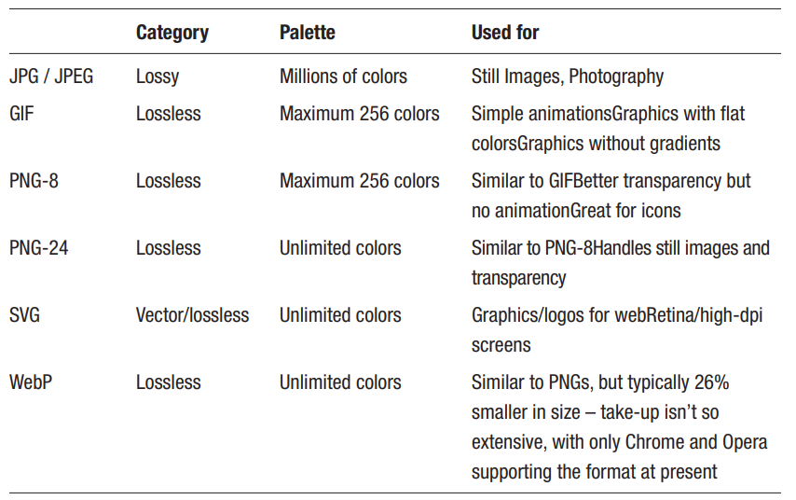

* **SVG:**
* Scalable Vector Graphics is an XML grammar for syllable graphics that can be used as an XML namespace.
* Scalable graphics allows for uniform dynamic pixel sizing for graphics.
* Graphic content can be stand-alone, referenced or included inside of other SVG graphics allowing for a complex illustration to be built in parts and possibly by several different people.
* Scalable to allow for different display resolutions i.e. content magnification to aid people with low vision.
* Scalable meaning 🡺 can grow to include a large number of users, files and/or application and still be efficient and effective.
* Vector graphics have geometric objects like lines and curves giving greater flexibility than raster-only formats (JPG, PNG) that store information for each and every pixel of the graphic.
* Vector formats can include raster images as well as geometric objects and combine them with vector information.
* SVG provides a rich, structured description of vector and mixed vector/raster graphics allowing it to be used in a stand-alone function or as an XML namespace with other grammars.
* SVG is a web format that allows content developers to create two dimensional graphics in a standard way by using an XML grammar.
* **PDF and SVG**
* PDF and SVG can be thought of as languages that describe how to draw the shapes that make up a picture.
* PDF is not an ideal file format for use on the web.
* It would be possible to use PDF purely for its graphics capabilities, embedding images in HTML documents but browsers do not support this.
* SWF 🡪 used for still vector images.
* SVG is xml while SWF is a binary format.
* SVG is for implementing web vector graphics.
* **Conversion between vector Image and raster image**
* Converting vector graphics into raster images is allowable.
* Converting raster (bitmaps) images is difficult.
  + Since it is based on **computing the bounds of a bitmapped image or the shapes of colors** within an image
  + **Then derive the polygon object that describes the image.**

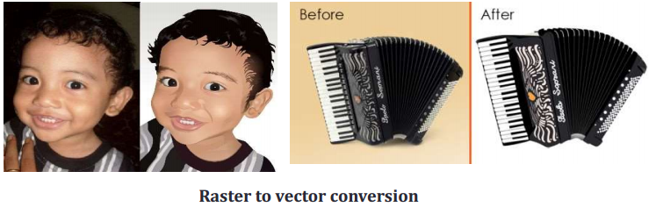

* **Comparison of bitmap(Raster) and vector Image**

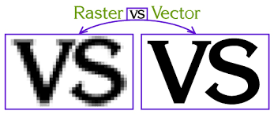

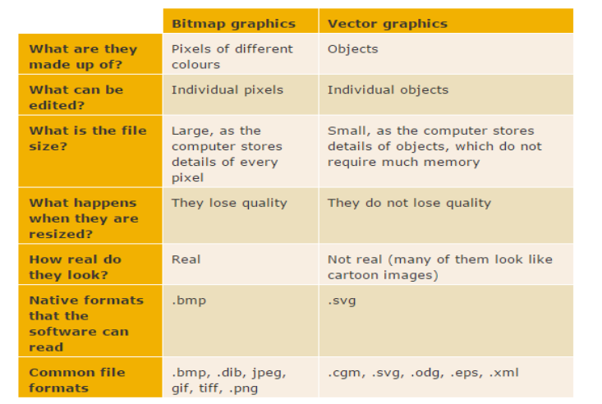

**Images, audio and video formats**

* Audio

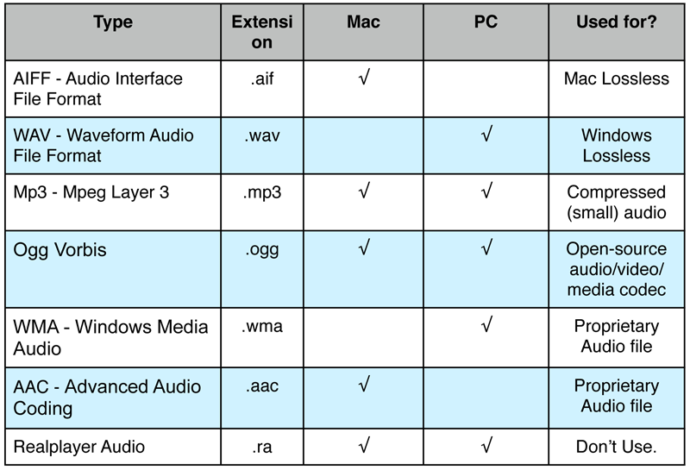

* **Video**

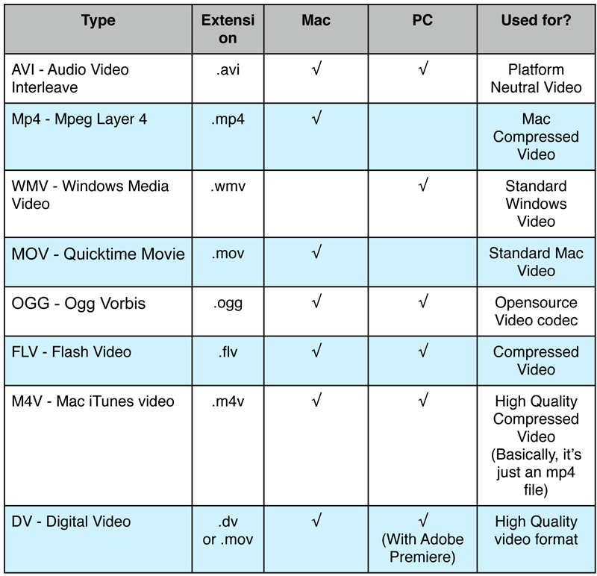

* **Images**

